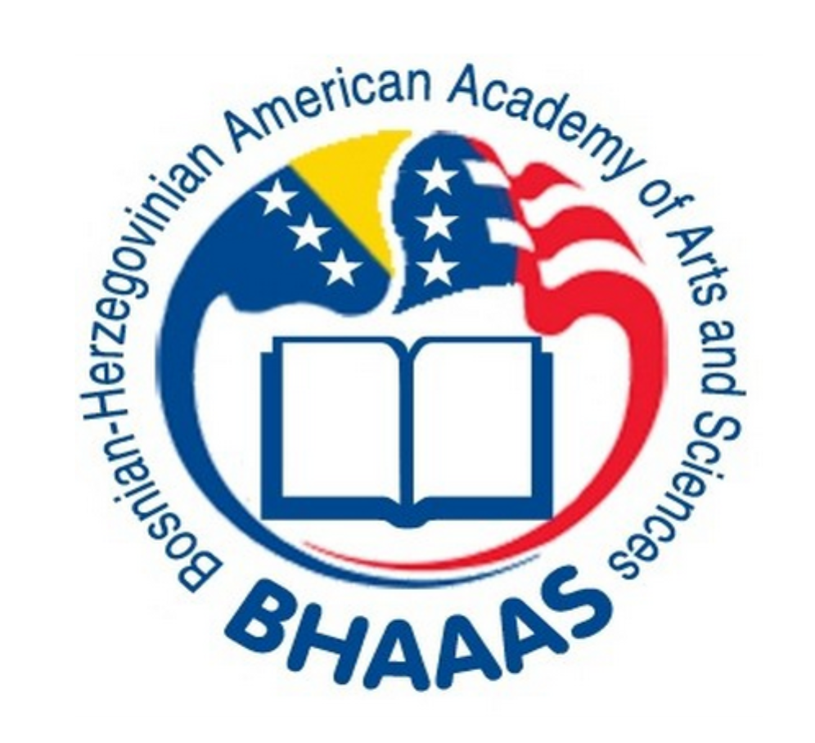

International Symposium in Family Medicine

21.05.2014, Bihac, Bosnia&Herzegovina

COURSE DIRECTORS: AndiArnautovic (BHAAAS) Katmerka Ceric (Bihac)
Muhamed Durakovic (BHAAAS)

VENUE: University of Bihac , Amphitheater 2, Pope Ivan Paul II 1/2 Street

THEME: One day symposium of the Family Medicine with reviewed of local, regional and global challenges and personal experiences in daily practice and different fields of family medicine

TIME FOR LECTURES: total 20 min (15 min presentation/powerpoint and 5 min for questions)

PARTICIPANTS: The symposium is intended for physicians, medical students, public health students, nurses, and technicians

8:30- 9:00 Registration of participants

AGENDA:

FOREWORD: OPENING/WELCOME SPEECHES

9:00-9:20 Andi Arnautovic, Katmerka Ceric, Muhamed Durakovic

UNIVERSAL GOALS- LOCAL, REGIONAL, AND GLOBAL STRUGGLES

Chairman: Andi Arnautovic, Muhamed Durakovic, Irena Jokic

9:20-9:40 SelimToromanovic(Bihac): The Current Position of the Health Care as the Pillar of Primary Care and Implementation of Family Medicine in their Work

9:40-10:00 Katmerka Ceric (Bihac): Where is Family Medicine situated in the US canton

10:00-10:20 Arif Smajkic (Sarajevo): Presumptions for Construction of Leadership Role of the Family Medicine Physician for Family Care Safety and Population Designation

10:20-10:40 Irena Jokic (Sarajevo: Evaluation of Selected Fields of Primary Care in the Federation of BiH

10:40 -11:00 Muharem Zildzic (Tuzla): Implementation of Quality in Family Medicine Practice in BiH

11:00- 11:20 Melida Hasanagic (Mostar): Basic Prerequisites for Credentials of Family Medicine Teams

11:20-11:40 Andi Arnautovic (Chicago, USA): Review of the Planned Transformation of the Health Care System in the USA

11:40- 12:00 Besima Rakic (Tesanj): HOPE Program in the Tesanj Region

12:00-13:20 LUNCH BREAK

APPLIED MEDICINE

Chariman: Azra Durakovic,Zarema Obradovic, Nizama Salihefendic

13:20- 13:40 Nizama Salihefendic (Tuzla, BiH ): Significance of Urgent Ultrasonography in Clinical Practice

13:40-14:00 Zarema Obradovic (Sarajevo): Diseases Transmitted by Vectors- Global Threat

14:00-14:20 Muhmed Durakovic (Minneapolis, USA): Diabetes and Pregnancy (Gestational Diabetes)

14:20-14:40 Munevera Becirevic(Tuzla,BiH): Depression as a factor of Cardiovascular Risk

14:40-15:00 Ermina Kalebic (Sarajevo,BiH): Application of Interventional Preventive Programs for Chronic Diseases

15:00-15:20 Azra Durakovic (Minneapolis, USA): Preoperative Medicine

15:20-15:40 S.Gaco,H. Halilovic,S.Muminovic,Z. Toromanovic, D.Hukic (Bihac): Polytraumatic Lesions of the Lung, Enlarged Small Intestine, and Stomach with Complications/Infection with Gaseous Gangrene

15:40-16:00 Jasmina Cepic (Bihac): Quality Management in Health Care with a Special Look on Quality System Management at Public Health Institutions within the US Canton

16:00-16:20 Amela Keco, Zaim Jatic (Sarajevo): Family Practice Physician and Problems Present with Diabetic Patient

16:20-16:40 Nedim Bahtić ( Bosanska Krupa): Problems (frustrations) in daily work of the first independent (private) Family Practice – Speciality Clinic in B&H Federation

16:40-17:20 SIMILARITIES AND DIFFERENCES OF TWO HEALTH CARE SYSTEMS . THE ROLE OF THE FAMILY PRACTICE PHYSICIAN IN THE US AND BIH - Round Table Discussion

Moderators: Andi Arnautovic, Azra Durakovic

17:00- Closing of the Symposium – Andi Arnautovic

SOCIAL HOUR TO FOLLOW

